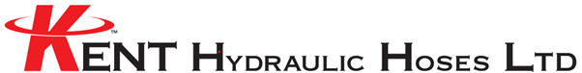

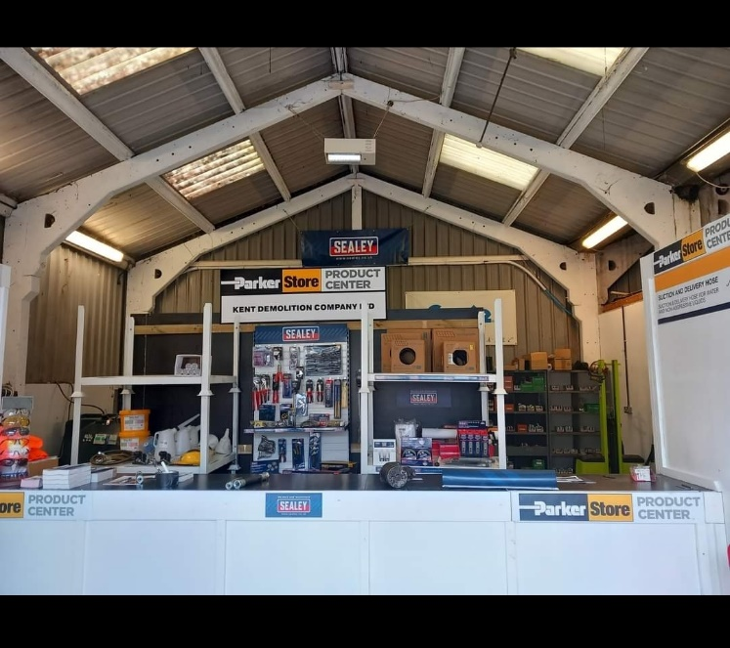We are happy to be offering all Southern Farmers Members a 5% Discount on our hoses, fittings, and lubricants at our Trade Counter. We are based in Wrotham, Sevenoaks and offer a fast, reliable service to both the farming and industrial market.

Kent Hydraulic Hoses Ltd

1 Borough Green Rd

Wrotham, Sevenoaks

TN15 7RD

01732 885543

Enquiries@kenthydrualichoses.co.uk